Pizza Sales Queries:

KPIS
- Total Revenue :
SELECT SUM(total_price) as total_revenue
FROM pizza_sales
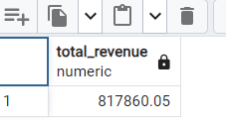
- Average order value :
SELECT SUM(total_price) /COUNT(DISTINCT order_id) as avg_order_value
FROM pizza_sales

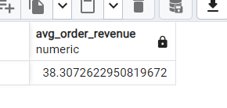
3 Total Pizza Sold :
SELECT SUM(quantity) as total_pizza_sold
FROM pizza_sales

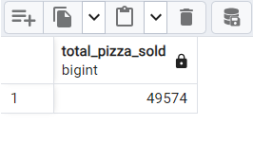
4)Total orders :
SELECT COUNT(DISTINCT order_id)
FROM pizza_sales
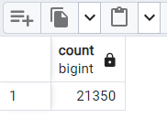

5) AVERAGE PIZZA PER ORDER:
SELECT(CAST(SUM(quantity) as DECIMAL(10,2)) /
(CAST(COUNT(DISTINCT order_id) DECIMAL(10,2)) AS DECIMAL(10,2)) as avg_pizza_per_orders
FROM pizza_sales
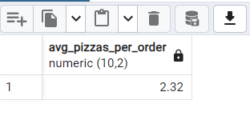

CHARTS REQUIREMENTS:
1)Daily trends for total orders by days:
SELECT
TRIM(TO_CHAR(order_date, 'Day')) AS order_day,
COUNT(DISTINCT order_id) AS total_orders
FROM pizza_sales
GROUP BY order_day
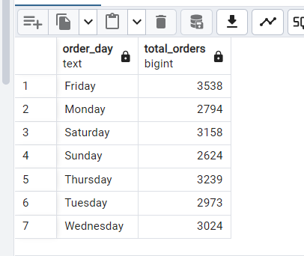
2) Trends by Months :
SELECT
TRIM(TO_CHAR(order_date, 'Month')) AS month_name,
COUNT(DISTINCT order_id) AS total_orders
FROM pizza_sales
GROUP BY month_name
ORDER BY total_orders DESC

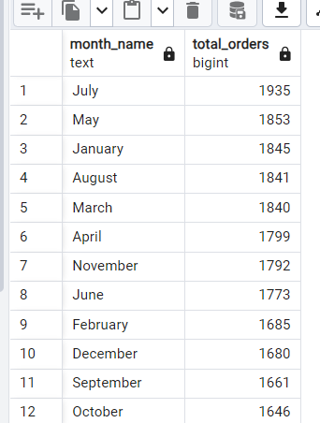
- % of sales by category :
SELECT pizza_category,
ROUND(SUM(total_price), 2) AS total_revenue,
ROUND(SUM(total_price) * 100.0
/ (SELECT SUM(total_price) FROM pizza_sales),2 ) AS pct
FROM pizza_sales
GROUP BY pizza_category
ORDER BY total_revenue DESC;

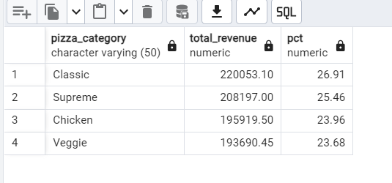
4) % OF sales by PIZZA SIZE :
SELECT pizza_size, CAST(SUM(total_price) AS DECIMAL(10,2)) as total_revenue,
CAST(SUM(total_price) * 100 / (SELECT SUM(total_price) from pizza_sales) AS DECIMAL(10,2)) AS PCT
FROM pizza_sales
GROUP BY pizza_size
ORDER BY pizza_size

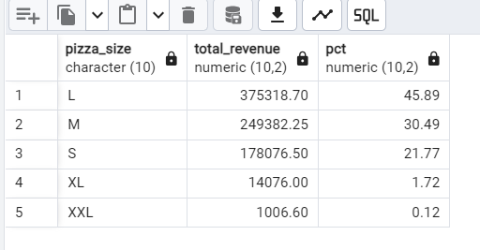
5) Total pizzas sold by pizza category:
SELECT pizza_category,SUM(quantity) as total_sold
FROM pizza_sales
GROUP BY pizza_category
order by total_sold DESC
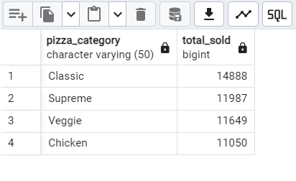

PAGE 2 OF Report

6)TOP 5 PIZZAS BY REVENUE:
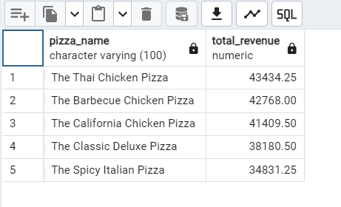
SELECT pizza_name,SUM(total_price) as total_revenue
FROM pizza_sales
GROUP BY pizza_name
ORDER BY total_revenue DESC
LIMIT 5
7)Bottom 5 by Revenue:
SELECT pizza_name, SUM(total_price) AS Total_Revenue
FROM pizza_sales
GROUP BY pizza_name
ORDER BY Total_Revenue ASC
LIMIT 5
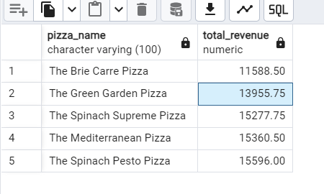

- Top 5 pizzas by Quantity:
SELECT pizza_name, SUM(quantity) AS Total_Pizza_Sold
FROM pizza_sales
GROUP BY pizza_name
ORDER BY Total_Pizza_Sold DESC
LIMIT 5
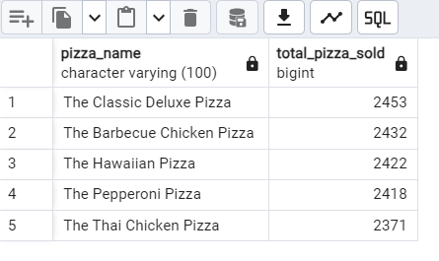
9)Bottom 5 by pizzas Quantity:
SELECT pizza_name, SUM(quantity) AS Total_Pizza_Sold
FROM pizza_sales
GROUP BY pizza_name
ORDER BY Total_Pizza_Sold ASC
Limit 5
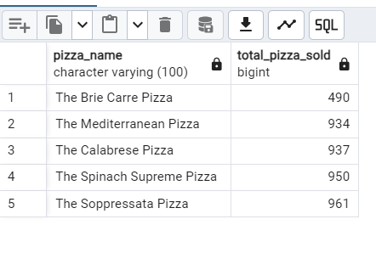
10)Top 5 pizzas by Total Order :
SELECT pizza_name, COUNT(DISTINCT order_id) AS Total_Orders
FROM pizza_sales
GROUP BY pizza_name
ORDER BY Total_Orders DESC
LIMIT 5

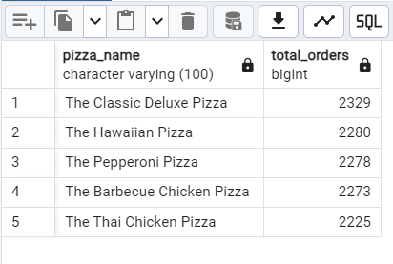

11)Bottom 5 pizzas by Total Order :

SELECT pizza_name, COUNT(DISTINCT order_id) AS Total_Orders
FROM pizza_sales
GROUP BY pizza_name
ORDER BY Total_Orders ASC
LIMIT 5

